DOCUMENT NO. | (provided by SMS document controller)
WORK DESCRIPTION | ……………..
WPP Number | (provided by NR specialist)
SCOPE: | This SWI is applicable for the worksite protection arrangements using SKS Blocking for routine ………. performed by ……..  Work activities include:
AUTHORISATIONS: | Protection Officer: Protection Officer Level 1 or higher  Handsignallers: Engineering Handsignaller Level 2.
SAFETY CONTROLS – Signal Key Switch Blocking (SKS) arrangements: | For work on the ….. line, the worksite is protected by:  - ….. Signal at STOP with the Signal Key Switch removed for the …… line.  - A Lookout established at ………. Watching for rail traffic from the ….. line.
PRESTART REQUIREMENTS: | Protection Officer assessment checklist must be completed before instructions in this SWI are followed.  Tools and equipment required:  Protection Officer requires a phone to contact the Signaller.  Radios
FURTHER INFORMATION: | NWT 300 Planning work in the Rail Corridor  NWT 320 Signal Key Switch Blocking  NPR 753 Using Signal Key Switch Blocking  NPR 754 Using a Signal Key Switch  NGE 200 Walking in the Danger Zone  NLA XXX

Protection Officer assessment checklist
Protection Officer’s name: |  |  | Yes  (Tick if Yes)
This document has not expired 12 months beyond the issue date.
On-site safety assessment has been completed and additional hazards and controls recorded on the pre-work briefing (Page 3).
SWI details and protection arrangements have been reviewed and validated for the assessed worksite location.
Corridor Safety Number | Protection Officer Signature | Date

 | Warning  If an above item does not apply, the Protection Officer must not use this Safe Work Instruction. A new worksite protection plan must be completed in accordance with NRF 014 Worksite Protection Pre-work briefing and NRF 015 Worksite Protection Plan.

Worksite Protection Pre-work Briefing
Briefing date: | / /

Protection Officer details
name |  | signature |  | contact No.

Work location:

Scope of work:

Worksite protection: | Signal Key Switch Blocking | Refer to Worksite Protection Plan for details

Hazards (e.g. environment, plant, equipment, human error) | Controls (to be implemented to eliminate or reduce the risk to the lowest practicable level) | Person responsible for Control
Approaching rail traffic | SKS Blocking implemented.  Workers must remain within worksite limits. | Protection Officer
Adjacent live lines | Designated work and walk areas as instructed by the Protection Officer. Workers must remain within the worksite limits whilst work is being performed. | Protection Officer
Access to / Egress from worksite | Protection Officer will assess and instruct when it is safe for workers to use NGE 200 Walking in the Danger Zone to move to and from the worksite or safe place. | All
Mobile phone distraction | Mobile phone usage is only allowed in the danger zone when required for work purposes only.  Mobile phones may be used only in a safe place after informing the Protection Officer. | All

A final site inspection has been conducted immediately before commencing work, and any new hazards and controls have been included.

Workplace Supervisor details

name |  | contact No.

Emergency assembly point: | Access Gate | SWMS/SWI Ref #:

First aid kit location: | Sydney Trains work vehicle | First aider:

Workplace Supervisor acknowledgement

The Workplace Supervisor acknowledges that all identified WHS and rail safety hazards have the appropriate controls in place to manage and/or eliminate the hazards. | Yes | signature

Participant Acknowledgement

NOTE: Recipients of the briefing are to question the Briefer if they don’t understand any part of this briefing.
All workers listed below acknowledge that they:
1. have been inducted to the site  2. are free from alcohol and drugs  3. are free from the effects of fatigue  4. hold the applicable and current Rail Safety Worker Authorisation, trade licence and/or induction record e.g. Construction Industry Induction  5. must wear the appropriate Personal Protective Equipment (PPE) |  | 6. have been briefed on the contents of the Worksite Protection Plan  7. have been shown the Worksite Protection Plan diagram  8. understand the kinds and limits of worksite protection in place  9. have been briefed about any new hazards and controls identified during the final site inspection (final site inspection must be conducted immediately before commencing work)
Mark each check box below with a tick if the item applies or a cross if the item does not apply.
have been informed of the requirements of the electrical permit (if required)  have been briefed on the SWMS/SWIs/documented safe work practice for the job  have been instructed in the controls recorded in this document and SWMS/SWIs |  | have been made aware of any hazardous materials/substances on site  have been briefed on Safety Data Sheets (SDS)  have been briefed on the WHS Management plan  have been briefed on the hazards of adjoining worksites/processes.
Name | Signature | Time of briefing:  hh:mm | Amendment briefing:  hh:mm and initial

Worksite Protection Plan – SKS Blocking
Protection Officer details
name |  | signature |  | contact No.

RSW or RIW No. |  | designation | Planned duration

Workplace Supervisor details:

Type of work:

Worksite location
on the |  |  |  | between |  | and
on the |  |  |  | between |  | and
Minimum Warning Time Calculations
sec | +  + | sec | + | 10 sec | = Minimum Warning Time  (MWT) | sec |  | km/h |  | metres
See Time (S) |  | Move Time (M) |  | Safe Time | (S+M+10 sec = MWT) |  |  | Track speed |  | Minimum Sighting Distance as calculated
Note – Additional MWT calculations can be recorded in the Protection Officer’s Diary.
Handsignaller details (tick the applicable locations)
1 | name |  |  | Sig/km | 
2 | name |  |  | Sig/km
3 | name |  |  | Sig/km
4 | name |  |  | Sig/km
5 | name |  |  | Sig/km
6 | name |  |  | Sig/km
7 | name |  |  | Sig/km
8 | name |  |  | Sig/km

Assurances (confirm the details provided by the Signaller)
The last rail traffic to pass the protection was | rail traffic ID | The last known location of rail traffic is | location
Confirm that there is no approaching rail traffic between protection and worksite
Signaller Details
name |  | Panel |  | 02 XXXX XXXX
Notes
Protection Officer’s log, diagrams, notes and detailed instructions are over the next pages. These are to be read and followed as part of this worksite protection plan for Signal Key Switch Blocking.
Before allowing workers to enter the Danger Zone, confirm:
- all entry points into the affected portion of track have been reduced or protected
- the Handsignaller has removed the key from the signal key switch and the signal is at STOP
Line [if multiple / merge columns if single]  (circle) |  | Rail traffic ID | Arrival time | Departure time | SKS key removed time | Cleared worksite time

INSTRUCTIONS: | - Workers enter the rail corridor via …………..  - Protection Officer briefs workers about the worksite protection arrangements.  - Handsignaller placed at ……… Signal, on the……. line,  - Protection Officer contacts the Signaller at ……………. to request permission to use SKS Blocking.  - After permission is granted, Protection Officer instructs the Handsignaller to arrange the removal of the SKS key from the protecting SKS signal.  - Protection Officer confirms with the Handsignaller that the SKS key has been removed and the signal is displaying STOP.  - Protection Officer contacts the Signaller at …………… to confirm that rail traffic has been excluded from the affected portion of track.  - Protection Officer confirms with the Signaller:  - train running information for rail traffic planned to pass through the worksite,  - the Identification number of last rail traffic to enter the affected portion of track and its last known location,  - that there is no rail traffic approaching the worksite.  - Protection Officer informs Workplace Supervisor protection is in place.  - Workers start work.  - After work is complete, all workers move to a safe place.  - Protection Officer instructs the Handsignaller at the protecting SKS signal to restore the key.  - After Handsignallers have confirmed the SKS key has been restored and the signal is displaying PROCEED, Protection Officer contacts the Signaller at …………….. to end SKS Blocking.  - All workers egress the rail corridor via …………
ADDITIONAL DETAILS
KEY LOCATIONS  EXAMPLE ONLY | 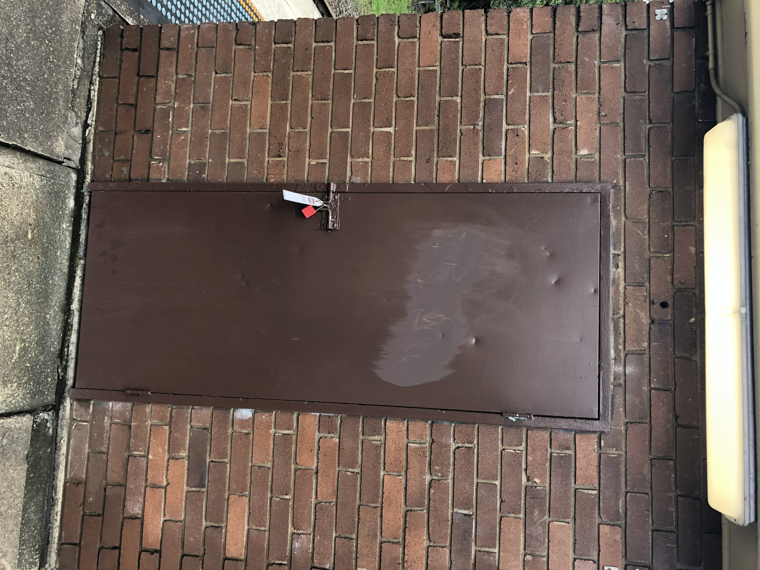  Image 1: Danger tag and dedicated padlock on Glenbrook control panel door. | 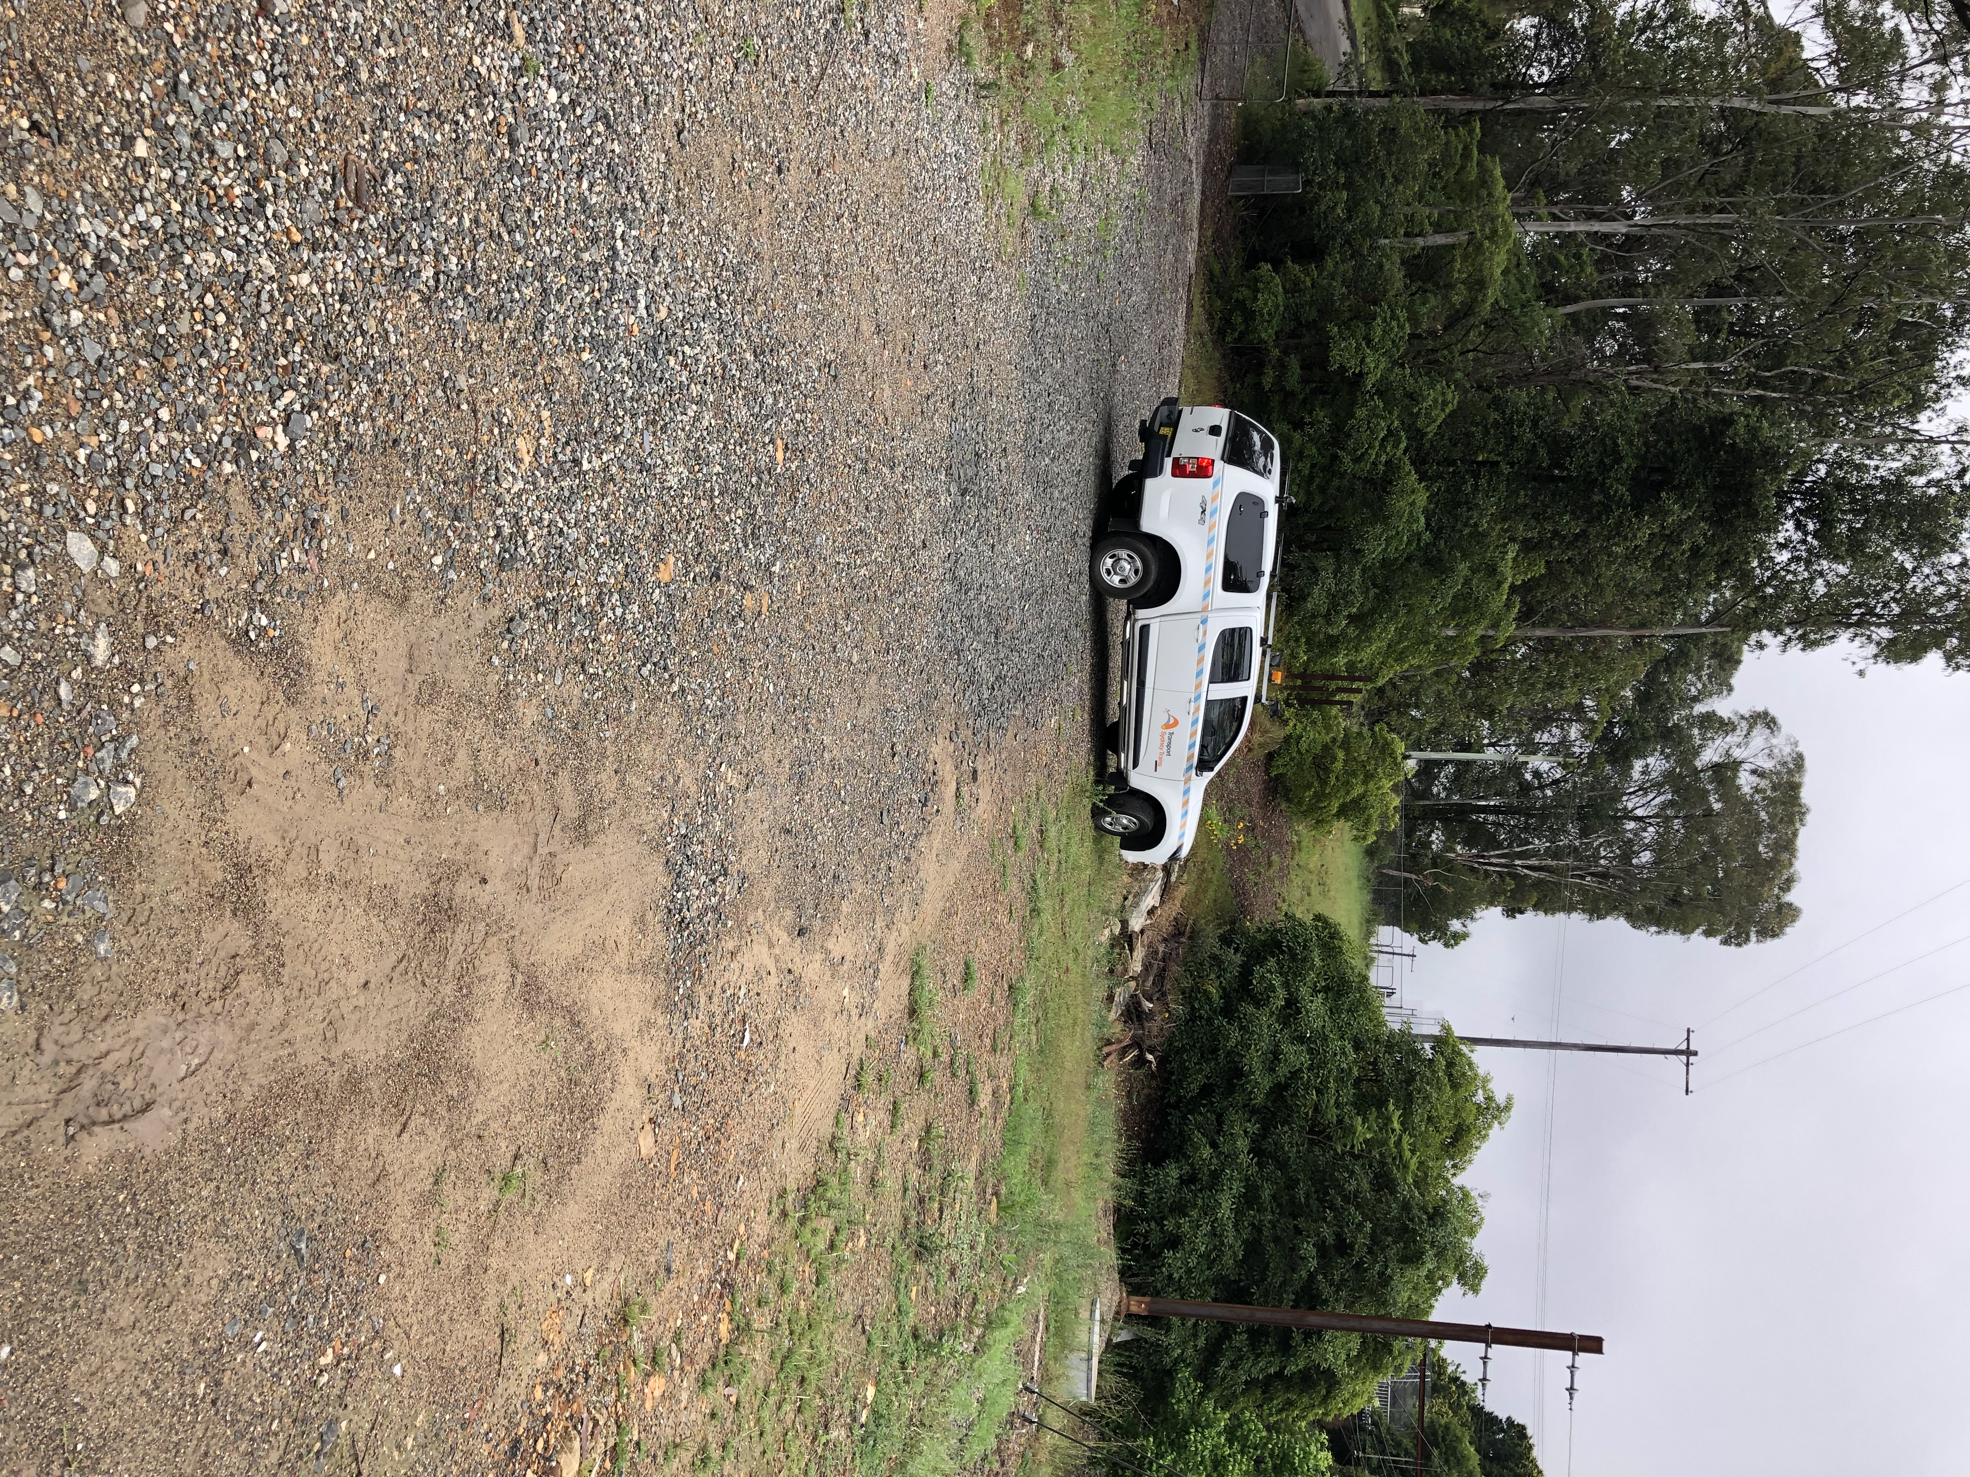  Image 2: Emergemcy Assembly Point. | 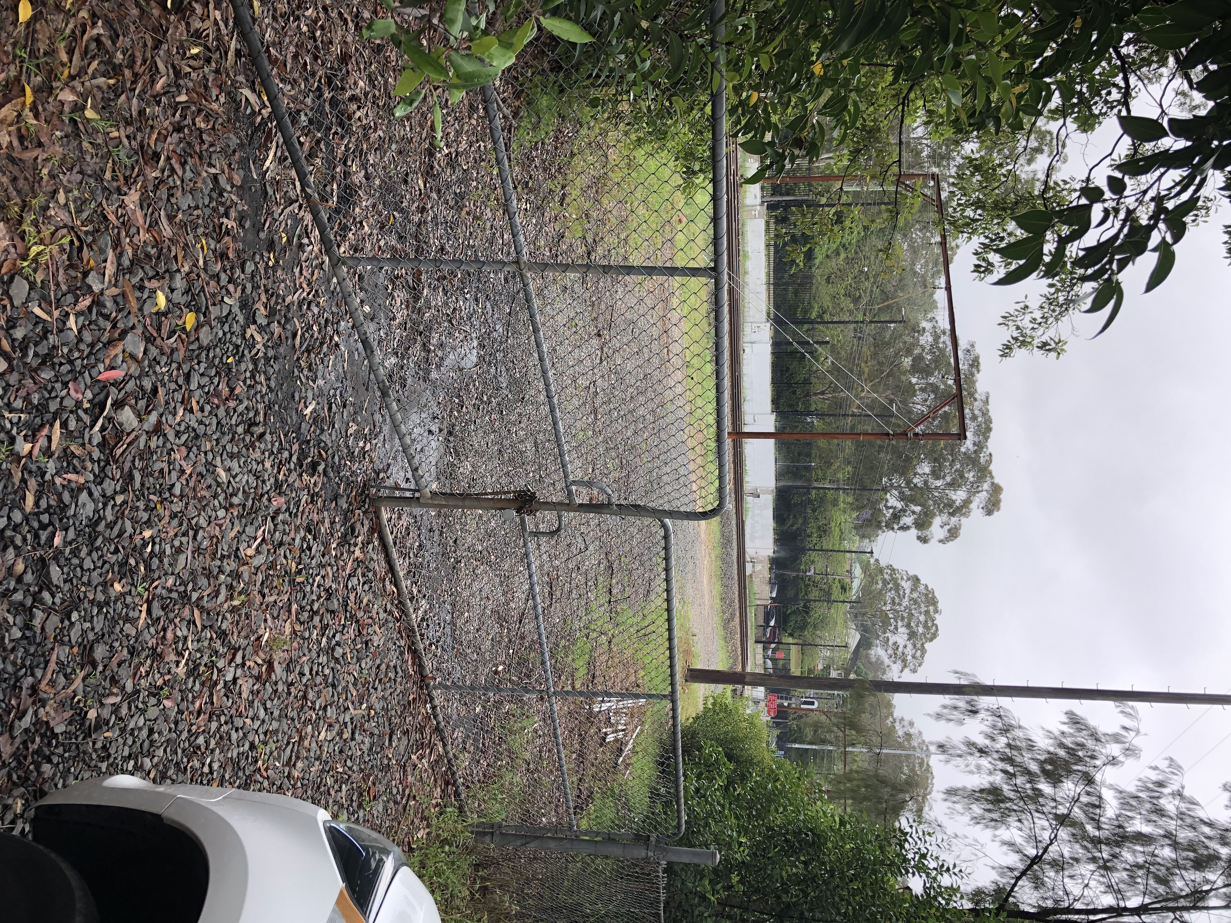  Image 3: Access gate W000 67.301 D to the Down Main West line worksite.

SKS SIGNAL LOCATIONS  EXAMPLE ONLY | 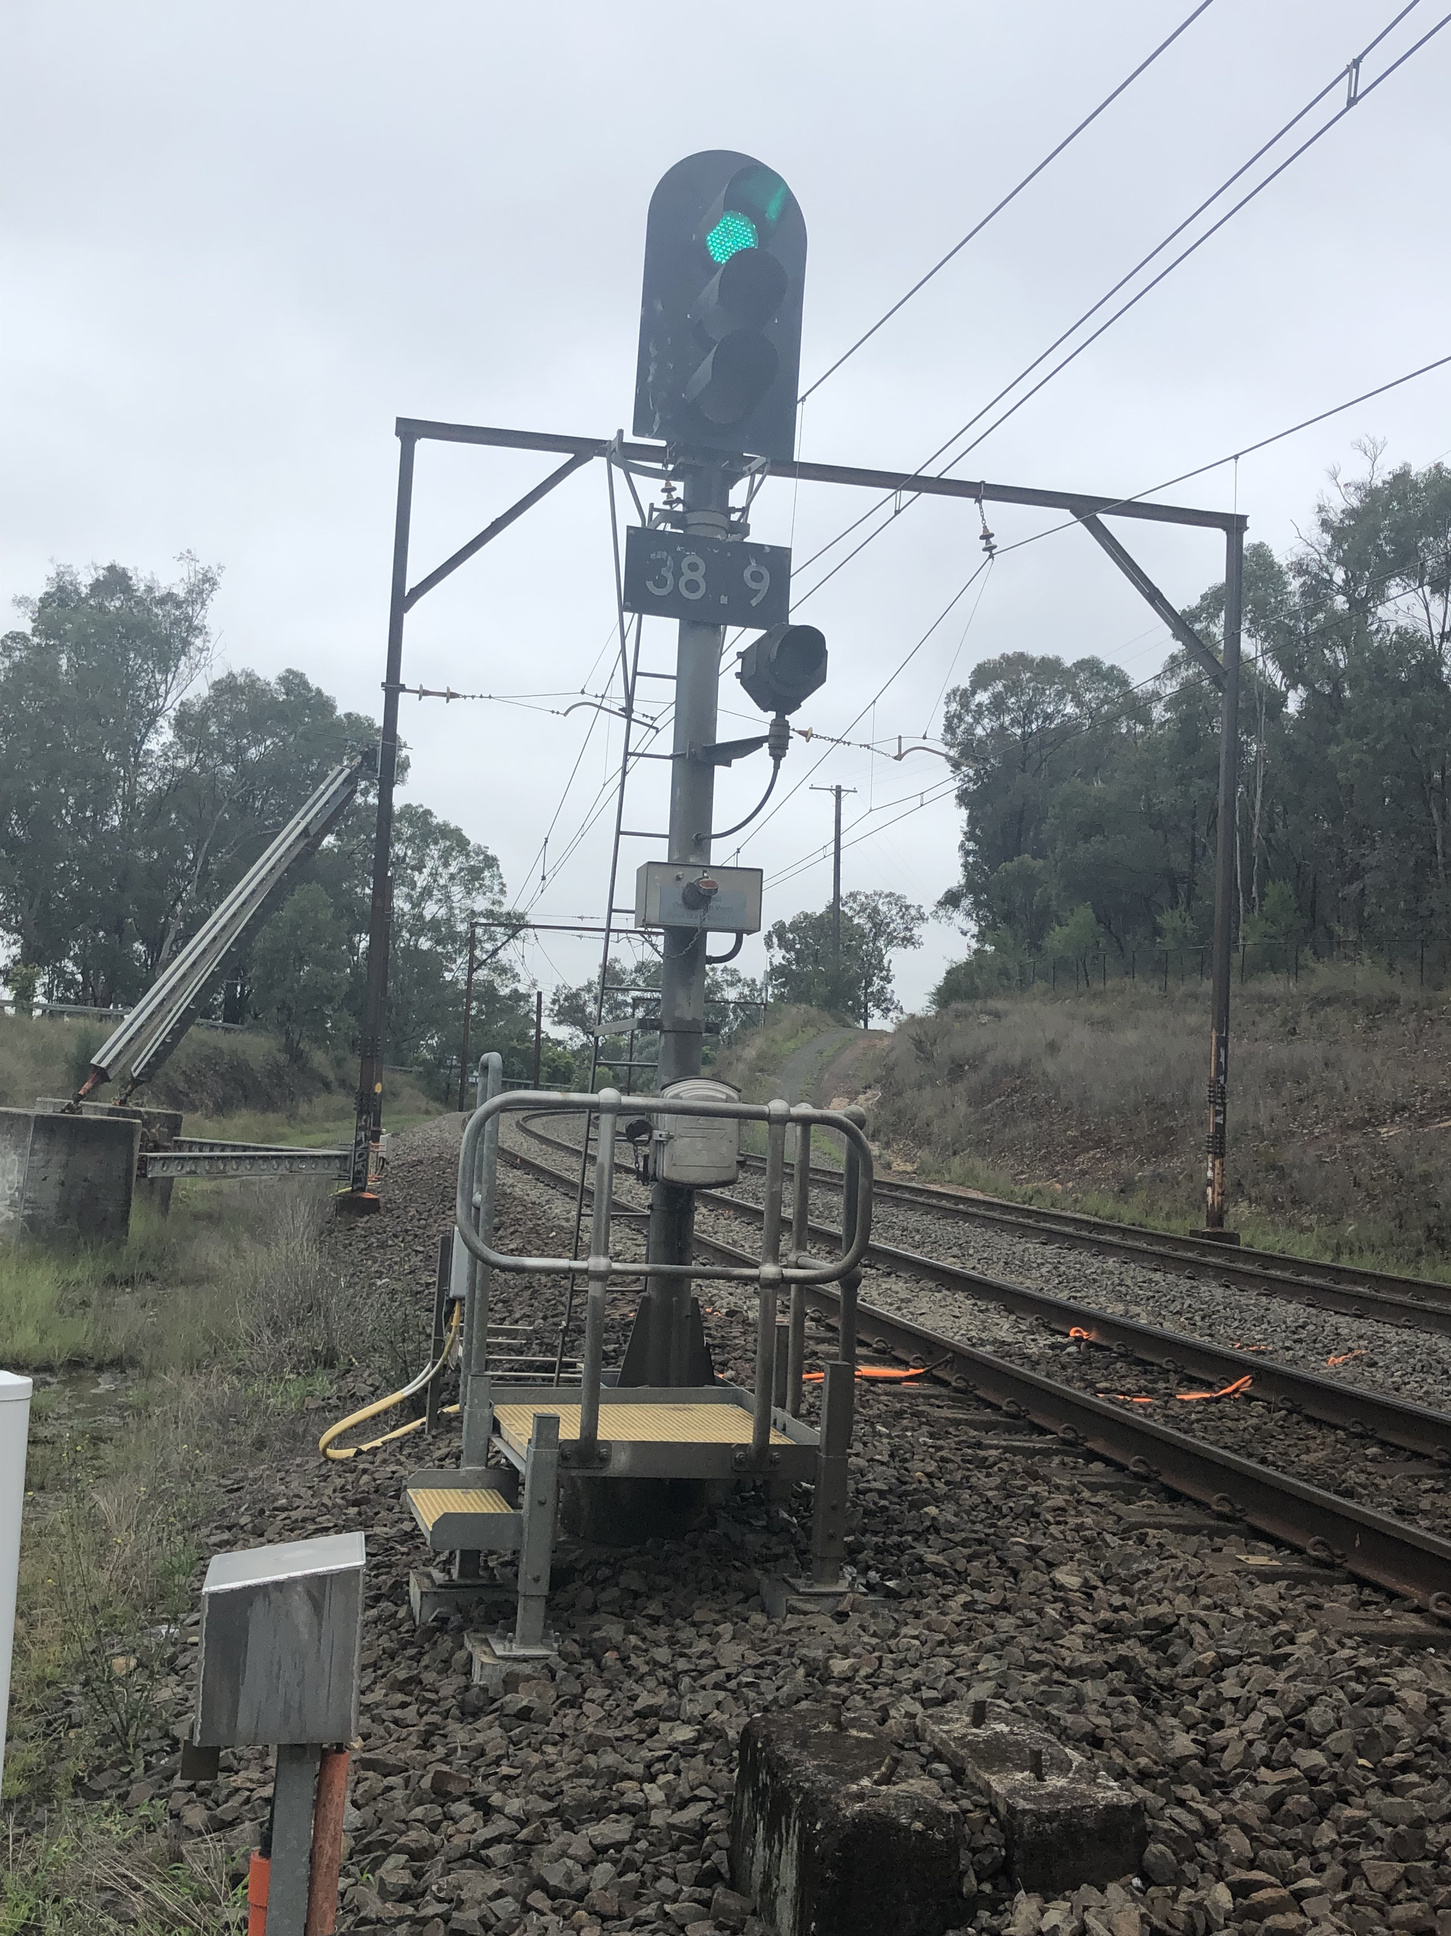  Image 4: 38.9 Signal on the Down Main West line | 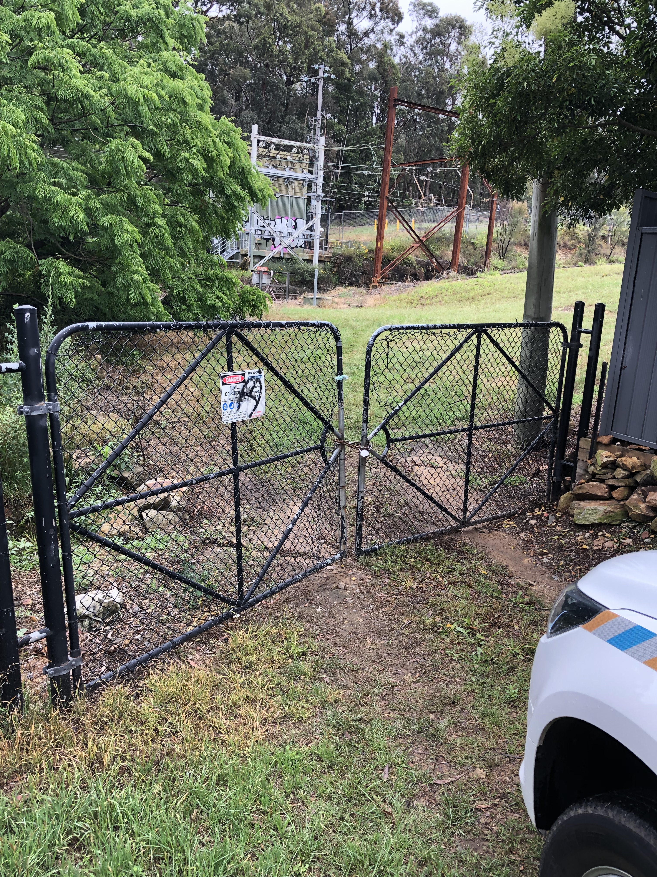  Image 5: Access gate W00 63.029 D to 38.9 Signal
 | 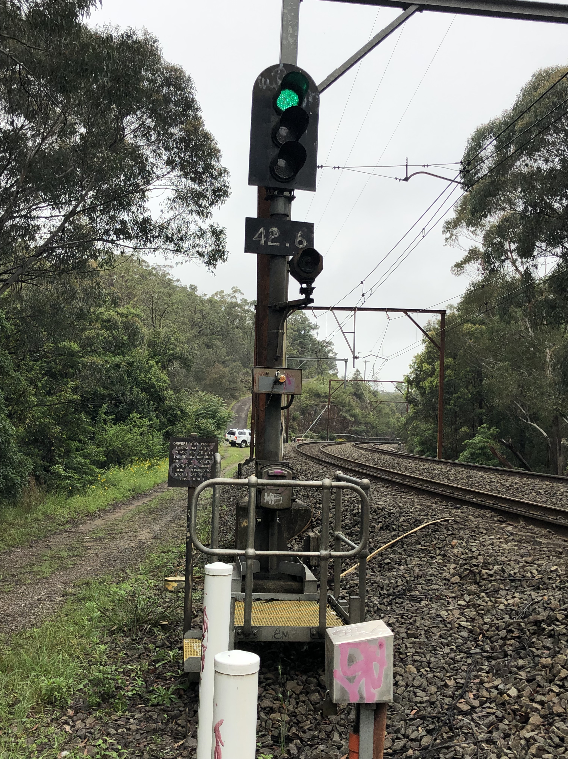  Image 6: 42.6 Signal on the Up Main West line | 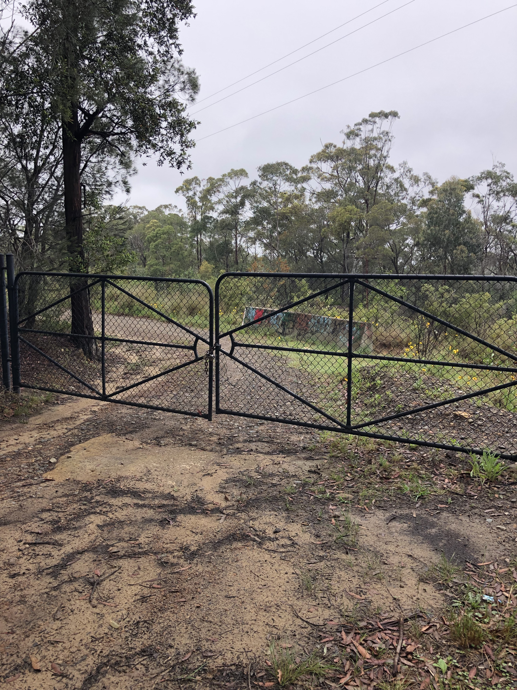  Image 7: Access gate W00 69.042 U to 42.6 Signal
Diagram
Insert diagram

Protection Officer’s diary
Date | Time | Notes

