DOCUMENT NO. | (provided by SMS document controller)
WORK DESCRIPTION | ……………..
WPP Number | (provided by NR specialist)
SCOPE: | This SWI is applicable for the worksite protection arrangements using lookout working concerning routine network maintenance, defect management and repair of assets within the limits specified below and in the attached plan.  Work activities include:  - Routine preventative and corrective work such as inspections and maintenance as appropriate for the type of protection being applied as part of this plan.
AUTHORISATIONS: | Protection Officer: Protection Officer Level 1 or higher  Lookout: Engineering Hand signaller Level 1 or higher or Protection Officer Level 1 or higher.
SAFETY CONTROLS: Lookout working arrangements | The nominated worksite location for Lookout Working includes the ………….  The nominated worksite location for Lookout Working is a moving worksite, where workers are working along the track within the limits of the nominated worksite location up to the where the Lookout is established.  As work moves along the track, the Protection Officer must assess the new location and:  - Establish and/or re-establish Lookouts as required to watch for approaching rail traffic from all entry points  - Designate and instruct which safe places the workers are to use as the work is completed along the work route within the worksite limits.
PRESTART REQUIREMENTS: | Protection Officer assessment checklist must be completed before instructions in this SWI are followed.  Tools and equipment required:  Protection Officer requires a phone to contact the Signaller.  Lookouts require a high-visibility arm sleeve and a whistle/horn.
FURTHER INFORMATION: | NWT 300 Planning work in the Rail Corridor  NWT 310 Lookout Working  NPR 711 Using Lookouts  NPR 751 Calculating Minimum Warning Time  NPR 712 Protecting work from rail traffic on adjacent lines  NGE 200 Walking in the Danger Zone  NLA 320 Broadmeadow - Newcastle Interchange  Lookout Working Prohibited Locations Register  NLA XXX

Protection Officer assessment checklist
Protection Officer’s name: |  |  | Yes  (Tick if Yes)
This document has not expired 12 months beyond the issue date.
SWI details and protection arrangements have been reviewed and validated for the assessed worksite location, including:
- On-site safety assessment has been completed for relevancy of works being undertaken
- The required protection details, environment and tasks are unchanged from the details of this SWI
The Protection Officer and Qualified Workers deploying qualifications are current and have practiced in the last 6 months. If not practiced, then a Rail Safety Coach must be contacted for guidance.
Corridor Safety Number | Protection Officer Signature | Date

Warning
If an above item does not apply, the Protection Officer must not use this Safe Work Instruction. A new worksite protection plan must be completed in accordance with NRF 014 Worksite Protection Pre-work briefing and NRF 015 Worksite Protection Plan.

Worksite Protection Pre-work Briefing
Briefing date: | / /

Protection Officer details
name |  | signature |  | contact No.

Work location:

Scope of work:

Worksite protection: | Lookout Working | Refer to Worksite Protection Plan for details

Hazards (e.g. Site specific hazards identified, including physical environment, human errors, plant and equipment) | Controls (to be implemented to eliminate or reduce the risk to the lowest practicable level) | Person responsible for Control
- Approaching rail traffic | Lookouts must be trained and competent to perform lookout duties.  Lookouts must be rotated if performing lookout for extended periods of time  Workers to remain within worksite limits as set out in this procedure.  Lookouts must be placed as per protection plan on page 8.  Workers are to stop work and move to a safe place immediately on being warned by the lookouts | Protection Officer  and  Lookout
- Live adjacent lines | Lookouts must provide warning to workers when rail traffic is approaching from the adjacent line in either direction. | Protection Officer  and  Lookout
Two - way running / multiple entry points into worksite | One Lookout placed watching each direction before work starts. Lookouts are to warn workers of approaching rail traffic, including rail traffic entering or travelling within the worksite. Workers are to stop work and move to a safe place. | Protection Officer  and  Lookout
Obstruction to Minimum Sighting Distance | Lookouts must provide warning to the workers whenever their line of sight is obstructed by passing rail traffic. Workers must stop work and move to a safe place and reassess positioning and method | Protection Officer  and  Lookout
Adjoining/Surrounding Worksites | Lookouts must have two independent audible warning devices that can be heard by workers over any noise generated by adjoining/surrounding worksites.  Lookouts are to provide warning if their line of sight is obstructed by adjoining/surrounding worksites. | Protection Officer  and  Lookout
Access to / Egress from worksite  Slips, trips, falls and hazards carrying equipment | Access and egress points must be agreed prior to entering the danger zone, consideration should be given to ease of access and safest possible entry and exit points.  Protection Officer will assess and instruct when it is safe for workers to use NGE 200 Walking in the Danger Zone to move to the worksite or safe place. | All
Mobile phone | Mobile phones use is not permitted in the danger zone unless being used by maintenance staff for critical maintenance communications or recording of defects. | All

Workplace Supervisor details

name |  | contact No.

Emergency assembly point: | Access Gate | SWMS/SWI Ref #:

First aid kit location: | Sydney Trains work vehicle | First aider:

Workplace Supervisor acknowledgement

The Workplace Supervisor acknowledges that all identified WHS and rail safety hazards have the appropriate controls in place to manage and/or eliminate the hazards. | Yes | signature

Participant Acknowledgement

NOTE: Recipients of the briefing are to question the Briefer if they don’t understand any part of this briefing.
All workers listed below acknowledge that they:
1. have been inducted to the site  2. are free from alcohol and drugs  3. are free from the effects of fatigue  4. hold the applicable and current Rail Safety Worker Authorisation, trade licence and/or induction record e.g. Construction Industry Induction  5. must wear the appropriate Personal Protective Equipment (PPE) |  | 6. have been briefed on the contents of the Worksite Protection Plan  7. have been shown the Worksite Protection Plan diagram  8. understand the kinds and limits of worksite protection in place  9. have been briefed about any new hazards and controls identified during the final site inspection (final site inspection must be conducted immediately before commencing work)
Mark each check box below with a tick if the item applies or a cross if the item does not apply.
have been informed of the requirements of the electrical permit (if required)  have been briefed on the SWMS/SWIs/documented safe work practice for the job  have been instructed in the controls recorded in this document and SWMS/SWIs |  | have been made aware of any hazardous materials/substances on site  have been briefed on Safety Data Sheets (SDS)  have been briefed on the WHS Management plan  have been briefed on the hazards of adjoining worksites/processes.
Name | Signature | Time of briefing:  hh:mm | Amendment briefing:  hh:mm and initial

Worksite Protection Plan – Lookout Working

Signaller details
name |  | ……….. |  | 02 XXXX XXXX
Protection Officer details
name |  | signature |  | contact No.

RSW or RIW No. |  | designation | Planned duration

Workplace Supervisor details:

Type of work:

Worksite location
on the
between |  | and
on the
between |  | and
Worksite assessment
Has the Lookout Working Prohibited Locations Register been consulted? Yes
Warning method
Horn/Whistle |  | Voice/Touch
Minimum Warning Time Calculations

Maximum track speed | km/h

Number of Lookouts used | X | Position of Lookouts | km | to | km
Number of additional Lookouts* used | X | Position of Lookouts | km | to | km
Note - Lookouts are relocated to positions within these KMs as workers move along the worksite.

sec | + | sec | + | 10 sec |  | sec |  | km/h |  | metres
sec | + | sec | + | 10 sec | = Minimum Warning Time  (MWT) | sec |  | km/h |  | metres
sec | + | sec | + | 10 sec |  | sec |  | km/h |  | metres
See Time (S) |  | Move Time (M) |  | Safe Time | (S+M+10 sec = MWT) |  |  | Track speed |  | Minimum Sighting Distance as calculated
Note – Additional MWT calculations can be recorded in the Protection Officer’s Diary.

Where are the safe places identified for the Lookouts and the workers?
Lookouts:

Workers:

Ensure the workers have been briefed about these work details Yes

Diagrams, notes, and detailed instructions are over the next pages. These are to be read and followed as part of this worksite protection plan for Lookout Working.
INSTRUCTIONS: | - Workers enter the rail corridor via ……………..  - Protection Officer briefs workers about the worksite protection arrangements.  - Protection Officer contacts ………… and tells the Signaller about the use of Lookout Working.  - Establish Lookouts at designated locations.  - Workers start work up to designated locations.  - Workers move to safe place.  - Re-establish Lookouts at next designated location.  - Repeat steps 6-8 until work is complete.  - Workers move to a safe place.  - Recall lookouts.  - Workers egress the worksite via …………..  - Protection Officer contacts ………. to end Lookout Working.
ADDITIONAL DETAILS  EXAMPLE ONLY | Obstruction to Minimum Sighting Distance  Stabled rail traffic on any tracks and conditions on the day may obstruct minimum sighting distance. When this hazard is identified, workers must stop work and move to a safe place until the Protection Officer makes an assessment and relocates lookouts to achieve the required minimum sighting distance.
LOOKOUTS  EXAMPLE ONLY  (Delete rows if not required, add more rows if more photos are required) | 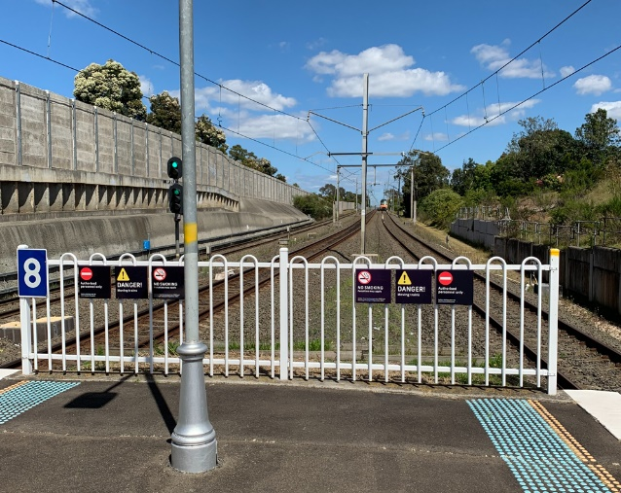Image 1: View towards Country end Platform 2 Sefton | 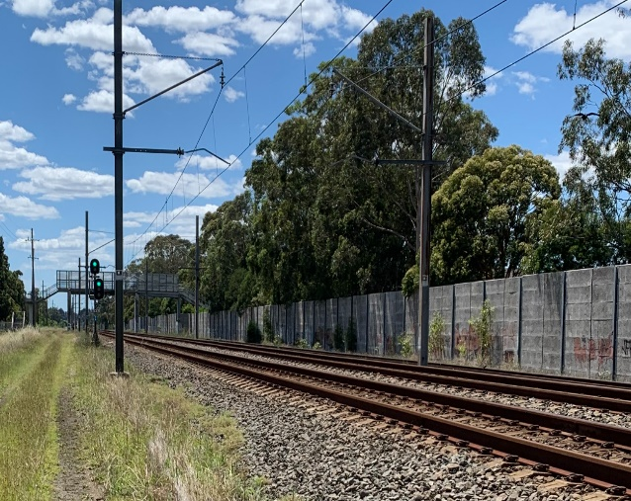  Image 2: View towards City end LC17.1 Signal
 | 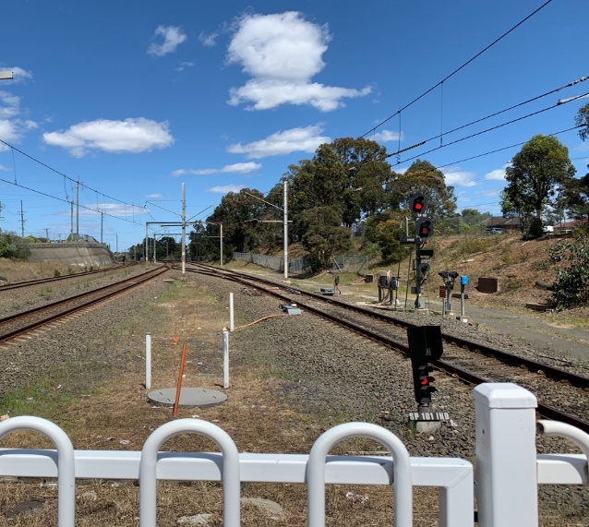  Image 3: View towards 224 Points from Villawood Station | 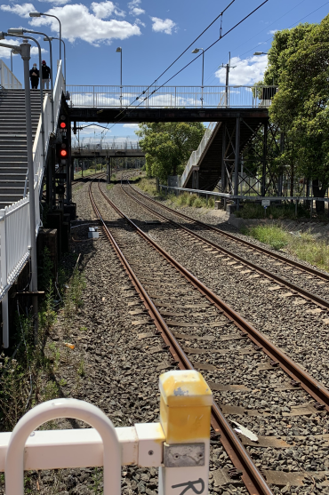  Image 4: View towards 222 points from Villawood Station
ACCESS / EGRESS  EXAMPLE ONLY  (Delete rows if not required, add more rows if more photos are required) | Image 5: Access Gate 21761 at S00 22.489 on the Up side. Double Gate at the end of Campbell Hill road Chester Hill

Diagram
Insert Diagram – Use the following figure in the diagram in place of Lookout icons.

Diagram
Diagram Example for Lookout Working moving worksites.
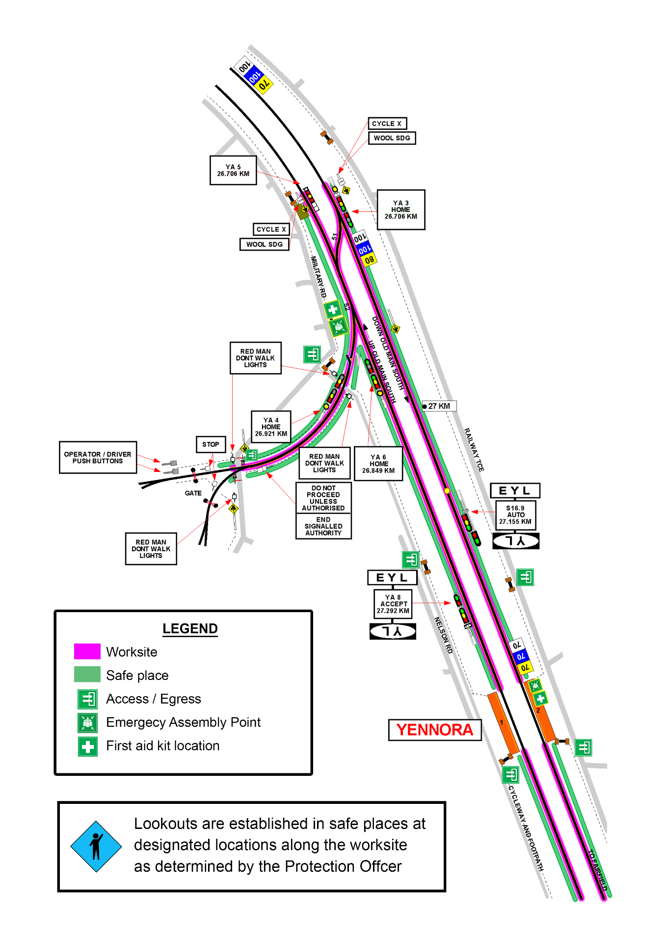

Protection Officer’s diary
Date | Time | Notes

