|  |  |
| --- | --- |
| DOCUMENT NO. | *(provided by SMS document controller)* |
| WORK DESCRIPTION | Routine Maintenance activities |
| WPP Number | *(provided by NR specialist)* |
| SCOPE: | Routine maintenance activities performed by … team.   * on the … and … lines between XXX.XXX km to XXX.XXX km * that does not involve the use of tools or equipment, or * using tools which can be easily and immediately removed from the track by one person and are light, non-powered hand tools, or light battery powered tools or devices. |
| AUTHORISATIONS: | **Protection Officer, ATWS Operator (Operator) & ATWS Installer (Installer):**   * Protection Officer (PO) Level 1 – 4, and * WATWS – Wireless Automatic Track Warning System   **Dedicated Lookout:** (PO) Level 1 - 4, or Handsignaller 1 - 2 |
| PERSONAL PROTECTIVE EQUIPMENT | * High visibility vest, boots, high visibility lookout sleeve |
| SAFETY CONTROLS – Lookout Working (ATWS) arrangements: | * Automatic Track Warning System (ATWS) - provides visual and audible warning for workers * ATWS sensor for … direction running on the line at XXX.XXX km * ATWS sensor for … direction running on the … line at XXX.XXX km * Dedicated lookout(s) at the worksite for unsignalled movements. * **IMORTANT!** * This document must not be used to install or adjust the ATWS sensors * All sensors in the plan and shown on the diagram must be connected to transmit a warning |
| PRESTART REQUIREMENTS: | * Refer to D2015-45354 Wireless ATWS (Automatic Track Warning System) to install or remove sensors |
| FURTHER INFORMATION: | *Refer to “D2015-45354 Wireless ATWS (Automatic Track Warning System)” for detailed instructions to set-up, connect, test and operate the ATWS system with pre-installed ATWS sensors*   * *NLA …* |

|  |  |  |
| --- | --- | --- |
| **Required ATWS Equipment** | | |
| **Item** | **Description** | **Quantity** |
| Aerial | Telescopic Aerial | 3 |
| Assembly Kit | Orange Bag with Tools | 1 |
| Battery ZA24-2.9 | Small battery for Junction Box & Transmitter | 8 |
| Device Frame | Protective Frame | 3 |
| F500-AB Junction Box | Receiver Device | 4 |
| F500-SEN Train Sensor | Sensor | 4 |
| Housing for Aerial | Housing for Telescopic Aerial | 3 |
| KF5-5 Extension Cable | Extension Cable (5m) for F500-SEN to F500-AB | 2 |
| Mobile Backpack | Harness for Device | 0 |
| Pouch | Pouch for small battery | 4 |
| Tripod | Tripod for Device | 3 |
| ZFS Radio Transmitter | Radio Transmitter Device | 2 |
| ZPW Warning Unit | Control & Warning Device | 1 |

|  |  |  |  |
| --- | --- | --- | --- |
| Protection Officer/Operator assessment checklist | | | |
| Protection Officer’s name: | | | Yes  *(Tick if Yes)* |
| This document has not expired 12 months beyond the issue date. | | |  |
| SWI details and protection arrangements have been reviewed and validated for the assessed worksite location, including:   * On-site safety assessment has been completed for relevancy of works being undertaken * The required protection details, environment and tasks are unchanged from the details of this SWI * All boxes have been ticked if applicable and crossed if not applicable * All fields have been completed | | |  |
| **Corridor Safety Number** | **Protection Officer Signature** | **Date** | |
|  |  |  | |

|  |  |
| --- | --- |
|  | Warning  *If an above item does not apply, the Protection Officer must not use this Safe Work Instruction. A new worksite protection plan must be completed in accordance with NRF 014 Worksite Protection Pre-work briefing and NRF 015 Worksite Protection Plan.* |

**Worksite Protection** **Pre-work Briefing**

|  |  |
| --- | --- |
| Briefing date: | / / |

**Protection Officer details**

|  |  |  |  |  |
| --- | --- | --- | --- | --- |
| name |  | signature |  | contact No. |

|  |  |
| --- | --- |
| Work location: |  |

|  |  |
| --- | --- |
| Scope of work: |  |

|  |  |  |
| --- | --- | --- |
| Worksite protection: | **Lookout Working (ATWS)** | Refer to Worksite Protection Plan for details |

|  |  |  |
| --- | --- | --- |
| **Hazards** (e.g. Site specific hazards identified, including physical environment, human errors, plant and equipment) | **Controls** (to be implemented to eliminate or reduce the risk to the lowest practicable level) | **Person responsible for Control** |
| **Crossing live lines** | A qualified Protection Officer (PO) or Access Corridor Safety (ACS) must make a safety assessment to cross live lines in accordance with NGE200 and supervise workers who do not hold the PO or ACS qualification. | Qualified PO/ACS |
| **Accessing Danger Zone to conduct plate test** | Use appropriate safety measures as validated by a PO. Refer to diagram for minimum safety assessment. | Qualified PO |
| **Electricity** | ATWS antennae not to encroach safe approach distance to overhead wiring | Operator |
| **Slips, trips, falls carrying ATWS equipment** | Use correct manual handling techniques, secure safety boots, clear obstacles for work area and agree a safe path. | All |
| **Approaching rail traffic** | Lookout Working using approved ATWS as assessed in the plan & diagram.  All points of entry have been validated and ATWS safety measures (sensors and point clips) have been installed.  On bi-directional lines the XYZ key has been removed.  Confirm with the Operator that the ATWS has been tested and is operational.  Workers immediately move to the designated safe place when warned.  Provide ALL CLEAR handsignal after workers and equipment are in a safe place.  After the warning has been cancelled, confirm there is no approaching rail traffic between the sensors and the worksite before allowing work to resume. | PO |
| **Ineffective ATWS warnings / Adjoning / surrounding worksites** | Test and confirm workers can see and hear the warning in the noisiest environment.  Explain the emergency warnings.  Workers to be within 50m of warning device.  Workers to remain within sight and hearing of warning unit at all times.  Radios not to be used near ATWS. | PO |
| **Train warning time longer than expected (stopping points or ATWS equipment fault)** | Workers to remain in a safe place until confirmed the ATWS is working correctly.  Contact the Signaller or visually confirm the line is clear between the sensors and the worksite.  Potential stopping points: … | PO |
| **Adjacent live lines** | Remain within the tracks being protected by the ATWS | PO |
| **Unsignalled movements in Yard limits** | Position lookout(s) in safe place.  Confirm minimum sighting distance can be achieved.  Test effective communication and be within sight and hearing of the workers. | PO / lookouts |
| **Second train warning cancelled in error** | Nominate a team member to confirm with the Operator when each rail traffic has completely passed the worksite.  Tell the PO and workers about the second train warning.  Cancel each warning after each train has completely passed the worksite. | Operator / nominated team member |
| **Distraction** | Obtain permission from PO to use electronic devices in the Danger Zone. | All |
| **Obstructions to safe place** | Agree on paths to reach designated safe places from the worksite. | PO |
| **Electrical storms** | Stop work immediately | All |

|  |  |  |
| --- | --- | --- |
| **Hazards** (e.g. Site specific hazards identified, including physical environment, human errors, plant and equipment) | **Controls** (to be implemented to eliminate or reduce the risk to the lowest practicable level) | **Person responsible for Control** |
|  |  |  |
|  |  |  |
|  |  |  |
|  |  |  |
|  |  |  |
|  |  |  |
|  |  |  |
|  |  |  |

**Workplace Supervisor details**

|  |  |  |
| --- | --- | --- |
| name |  | contact No. |

|  |  |  |  |
| --- | --- | --- | --- |
| Emergency assembly point: |  | SWMS/SWI Ref #: |  |

|  |  |  |  |
| --- | --- | --- | --- |
| First aid kit location: |  | First aider: |  |

**Workplace Supervisor acknowledgement**

|  |  |  |
| --- | --- | --- |
| The Workplace Supervisor acknowledges that all identified WHS and rail safety hazards have the appropriate controls in place to manage and/or eliminate the hazards. | Yes 🞎 | **signature** |

**Participant Acknowledgement**

|  |  |  |  |
| --- | --- | --- | --- |
| **NOTE**: Recipients of the briefing are to question the Briefer if they don’t understand any part of this briefing. | | | |
| All workers listed below acknowledge that they: | | | |
| 1. have been inducted to the site  2. are free from alcohol and drugs  3. are free from the effects of fatigue  4. hold the applicable and current Rail Safety Worker Authorisation, trade licence and/or induction record e.g. Construction Industry Induction  5. must wear the appropriate Personal Protective Equipment (PPE) | | 6. have been briefed on the contents of the Worksite Protection Plan  7. have been shown the Worksite Protection Plan diagram  8. understand the kinds and limits of worksite protection in place  9. have been briefed about any new hazards and controls identified during the final site inspection (*final site inspection must be conducted immediately before commencing work*) | |
| *Mark each check box below with a tick* 🗹 *if the item applies or a cross* 🗷 *if the item does not apply.* | | | |
| 🞎 have been informed of the requirements of the electrical permit (if required)  🞎 have been briefed on the SWMS/SWIs/documented safe work practice for the job  🞎 have been instructed in the controls recorded in this document and SWMS/SWIs | | 🞎 have been made aware of any hazardous materials/substances on site  🞎 have been briefed on Safety Data Sheets (SDS)  🞎 have been briefed on the WHS Management plan  🞎 have been briefed on the hazards of adjoining worksites/processes. | |
| **Name** | **Signature** | **Time of briefing:** hh:mm | **Amendment briefing:** hh:mm and initial |
|  |  |  |  |
|  |  |  |  |
|  |  |  |  |
|  |  |  |  |
|  |  |  |  |
|  |  |  |  |
|  |  |  |  |
|  |  |  |  |
|  |  |  |  |
|  |  |  |  |
|  |  |  |  |
|  |  |  |  |
|  |  |  |  |
|  |  |  |  |
|  |  |  |  |
|  |  |  |  |
|  |  |  |  |
|  |  |  |  |

**Worksite Protection Plan – Lookout Working**

**Signaller details**

|  |  |  |  |  |
| --- | --- | --- | --- | --- |
|  |  | **… Panel** |  | **02 XXXX XXXX** |

**Protection Officer details**

|  |  |  |  |  |
| --- | --- | --- | --- | --- |
| name |  | signature |  | contact No. |

|  |  |  |  |  |
| --- | --- | --- | --- | --- |
| RSW or RIW No. |  | designation | Planned duration |  |

|  |  |
| --- | --- |
| Workplace Supervisor details: |  |

|  |  |
| --- | --- |
| Type of work: | **Routine Maintenance Activities** |

|  |  |  |  |  |
| --- | --- | --- | --- | --- |
| **Worksite location** | | | |  |
| On the | **… line** | | | SingleBoxBlank |
|  |  | | |  |
| **between** | **…** | **and** | **…** |  |
|  | | | | |
| On the | **… line** | | | SingleBoxBlank |
|  | | | | |
| **between** | **…** | **and** | **…** |  |
|  |  |  |  |  |

**Worksite Assessment**

Has the Lookout Working Prohibited Locations Register been consulted? Yes 🞎

**Warning method**

|  |  |  |
| --- | --- | --- |
| ATWS |  |  |

**Minimum Warning Time Calculations**

|  |  |
| --- | --- |
| Maximum track speed | **…** km/h |

|  |  |  |  |  |  |  |
| --- | --- | --- | --- | --- | --- | --- |
| Number of ATWS Sensors used | 2 / 4 | Position of ATWS Sensors | **…** km | and | **…** km | |
|  |  |  |  |  |  | |
| Number of dedicated Lookouts used | 1 | Position of Lookouts | **…** km | To | **…** km | |
| **Note** - Lookouts are relocated to positions within these KMs as workers move along the worksite. | | | | | |

|  |  |  |  |  |  |  |  |  |  |  |  |
| --- | --- | --- | --- | --- | --- | --- | --- | --- | --- | --- | --- |
| **…** sec | + | **…** sec | + | **…** sec | ­  **= Minimum Warning Time (MWT)** | **…** sec |  | **…** km/h |  | **…** metres | **…** line |
| **…** sec | + | **…** sec | + | **…** sec | **…** sec |  | **…** km/h |  | **…** metres | **…** line |
| *See Time (S)* |  | *Move Time (M)* |  | *Safe Time* | *(S+M+10 sec = MWT)* |  |  | *Track speed* |  | *Minimum Sighting Distance as calculated* |  |

**Dedicated Lookout**

|  |  |  |  |  |  |  |  |  |  |  |  |
| --- | --- | --- | --- | --- | --- | --- | --- | --- | --- | --- | --- |
| 2 sec | + | 3 sec | + | 10 sec | = Minimum Warning Time (MWT) | 15 sec |  | 25 km/h |  | 105 metres |  |
|  |
| *See Time (S)* |  | *Move Time (M)* |  | *Safe Time* | *(S+M+10 sec = MWT)* |  |  | *Track speed* |  | *Minimum Sighting Distance as calculated* |

**Where are the safe places identified for the ATWS Operator, Lookouts and workers?**

|  |  |
| --- | --- |
| Lookouts: | **Up Cess for Up Main. Down Cess for Down Main.** |

|  |  |
| --- | --- |
| Workers: | **Up Cess for Up Main. Down Cess for Down Main.** |

**Confirm mandatory first train tests were completed for all sensors Yes** 🞎

**Ensure the workers have been briefed about these work details Yes** 🞎

NOTE: Diagrams and instructions that follow form part of this worksite protection plan.

*Tick if used* ◻ **Worksite on … & … lines**

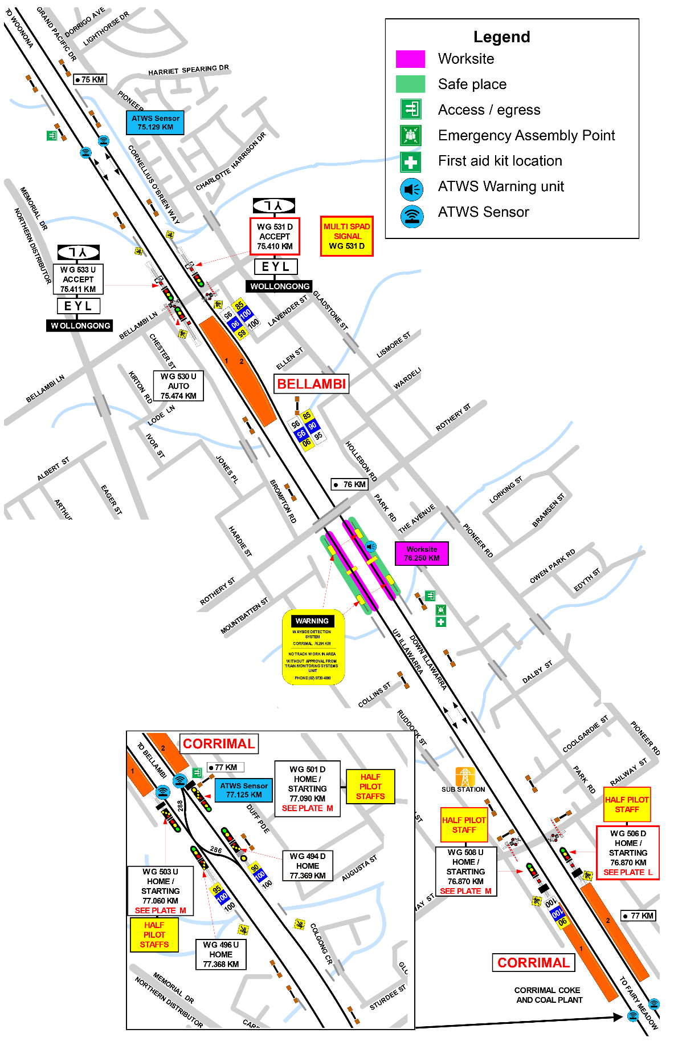

Conduct sensor plate test in accordance with NGE200 as a minimum. Safety assessment to be validated by PO.

Replace diagram – example only

Conduct sensor plate test in accordance with NGE200 as a minimum. Safety assessment to be validated by PO.

*Tick if used* ◻ **Worksite on … line**

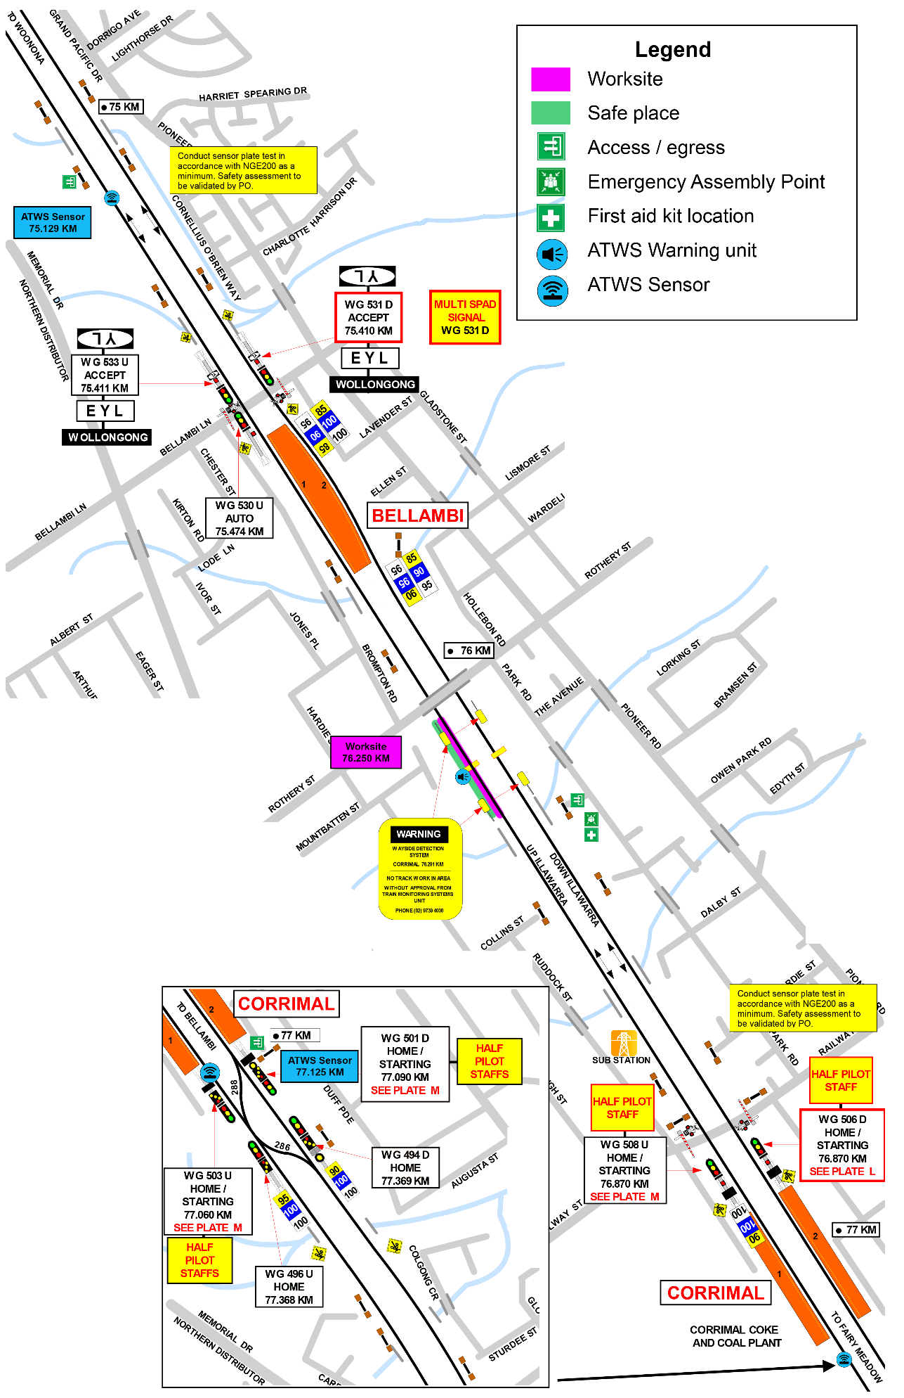

Replace diagram – example only

*Tick if used* ◻ **Worksite on … line**

Replace diagram – example only

|  |  |
| --- | --- |
| INSTRUCTIONS: | 1. Workers enter the rail corridor via access gate …. 2. Use assets to validate worksite location on … and … lines between XXX.XXX km to XXX.XXX km 3. Conduct WP Pre-work briefing to set-up ATWS. 4. Tell Signaller at … Panel about the use of lookout working with ATWS. |
| Tick if used ◻ | 1. Access Up Cess XXX.XXX km, verify sensor label & connect to sensor cable, calibrate with test plate, connect and turn on the transmitter. |
| Tick if used ◻ | 1. Access Up Cess XXX.XXX km, verify sensor label, connect to sensor cable, calibrate with test plate, connect & turn on transmitter. |
|  | 1. Place warning system on same side of tracks if working on one track only within sight & hearing of workers, conduct siren & light self test, & connect to transmitter(s). 2. Record first rail traffic movement test for each sensor on ATWS Check-sheet. 3. Conduct WP Pre-work briefing for lookout working with ATWS and confirm workers have seen and heard the warning. 4. Start work when advised by the PO, and move to the designated safe place when warned. 5. When work is complete, and workers and equipment are in a safe place, turn off and pack up warning unit |
| Tick if used ◻ | 1. Access Up Cess to turn off and pack up transmitter unit(s). |
| Tick if used ◻ | 1. Access Up Cess to turn off and pack up transmitter unit(s). |
|  | 1. Access … Cess for all workers to leave the rail corridor via access gate … 2. Tell Signaller at … Panel when work is completed and the workers and their equipment are clear of the Danger Zone. |

|  |  |  |
| --- | --- | --- |
| **Tick if used** ◻ | **Position of ATWS transmitter and sensor on … line at XXX.XXX KM** | |
| *Insert image*  Image 1: Transmitter and sensor installation location | | *Insert image*  Image 2: Sensor access using access gate … |
| Tick if used ◻ | Position of ATWS transmitter and sensor on … line at XXX.XXX KM | |
| *Insert image*  Image 1: Transmitter and sensor installation location | | *Insert image*  Image 2: Sensor access using access gate … |

**Protection Officer’s diary**

|  |  |  |
| --- | --- | --- |
| **Date** | **Time** | **Notes** |
|  |  |  |
|  |  |  |
|  |  |  |
|  |  |  |
|  |  |  |
|  |  |  |
|  |  |  |
|  |  |  |
|  |  |  |
|  |  |  |
|  |  |  |
|  |  |  |
|  |  |  |
|  |  |  |
|  |  |  |
|  |  |  |
|  |  |  |
|  |  |  |
|  |  |  |
|  |  |  |
|  |  |  |
|  |  |  |
|  |  |  |
|  |  |  |
|  |  |  |
|  |  |  |
|  |  |  |
|  |  |  |
|  |  |  |
|  |  |  |
|  |  |  |
|  |  |  |
|  |  |  |
|  |  |  |
|  |  |  |
|  |  |  |
|  |  |  |
|  |  |  |
|  |  |  |
|  |  |  |
|  |  |  |
|  |  |  |
|  |  |  |
|  |  |  |
|  |  |  |
|  |  |  |
|  |  |  |
|  |  |  |
|  |  |  |
|  |  |  |
|  |  |  |
|  |  |  |
|  |  |  |
|  |  |  |

*(This page is optional and may be separated and given to the assigned operator to assist set- up of ATWS equipment. Refer also to Refer to “D2015-45354 Wireless ATWS (Automatic Trak Warning System)” for detailed instructions.)*

|  |  |  |
| --- | --- | --- |
| ***Setup Stage 2: checklist for ATWS worksite warning unit*** | | |
| **Step** | **Task Description** | **Operator Check** |
| 1 | Confirm equipment is within inspection date |  |
| 2 | Confirm Audible level |  |
| 3 | Confirm and set Radio Channel for Warning unit |  |
| 4 | Book in ATWS sensor 1 |  |
| 5 | Book in ATWS sensor 2 |  |
| 6 | Book in ATWS sensor … |  |
| 7 | Perform Worksite Warning Test with all ATWS sensor |  |
| 8 | Ensure the workers have seen the visual warning and heard the audible warning |  |
| 9 | Select and Confirm Channel for the Radio Transmitter |  |
| 10 | Confirm worksite warning unit is operational with Installers and advise them to lock devices & remove key |  |

|  |  |  |
| --- | --- | --- |
| ***Setup Stage 1: Checklist for ATWS transmitter and sensor*** | | |
| **Step** | **Task Description** | **Installer Check** |
| 1 | Verify Track Label for location of sensor as per the Protection Diagram and Photos in this document |  |
| 2 | Confirm equipment is within inspection date |  |
| 3 | Sensor direction is per Worksite Protection Diagram and photos in this document |  |
| 4 | Connect sensor cable to junction box |  |
| 5 | Confirm all batteries are fully charged |  |
| 6 | Connect junction box to ZFS using channel T1-T4 |  |
| 7 | Commence calibration and automatic self- test |  |
| 8 | Perform function test using test plate |  |
| 9 | Confirm transmitter booked in to correct T- channel (T1-T4) |  |
| 10 | Select & confirm channel for the radio transmitter (AU3 OR AU4) |  |
| 11 | Perform worksite warning test using test plate |  |
| 12 | Lock device & remove key |  |