DOCUMENT NO. | (provided by SMS document controller)
WORK DESCRIPTION | ……………..
WPP Number | (provided by NR specialist)
SCOPE: | This SWI is applicable for the worksite protection arrangements using TWA for routine ………. performed by ……..  Work activities include:
AUTHORISATIONS: | Protection Officer: Protection Officer Level 3 or higher  Handsignallers: Engineering Handsignaller Level X.
SAFETY CONTROLS – Track Work Authority (TWA) arrangements: | For work on the ….. line, the worksite is protected by:  - A Handsignaller level X must be placed at …………. on the …..line.  - Handsignaller level X must be placed at …………. on the …..line.  - XXX points and XXX points must be clipped and locked.  When rail traffic enters the worksite limits from any direction all workers and equipment must stay clear of the Danger Zone until all rail traffic has passed the worksite limits and protection has been replaced.
PRESTART REQUIREMENTS: | Protection Officer assessment checklist must be completed before instructions in this SWI are followed.  Tools and equipment required:  Protection Officer requires a phone to contact the Signaller.  Handsignaller Level X require railway track signals, red flags/lights.
FURTHER INFORMATION: | NWT 300 Planning work in the Rail Corridor  NWT 306 Track Work Authority  NPR 702 Using a Track Work Authority  NGE 202 Handsignals  NPR 707 Clipping points  NPR 709 Using railway track signals  NPR 712 Protecting work from rail traffic on adjacent lines  NGE 200 Walking in the Danger Zone  NLA XXX ……..

Protection Officer assessment checklist
Protection Officer’s name: |  |  | Yes  (Tick if Yes)
This document has not expired 12 months beyond the issue date.
On-site safety assessment has been completed and additional hazards and controls recorded on the pre-work briefing (Page 3).
SWI details and protection arrangements have been reviewed and validated for the assessed worksite location.
Corridor Safety Number | Protection Officer Signature | Date

Warning
If an above item does not apply, the Protection Officer must not use this Safe Work Instruction. A new worksite protection plan must be completed in accordance with NRF 014 Worksite Protection Pre-work briefing and NRF 015 Worksite Protection Plan.

Worksite Protection Pre-work Briefing
Briefing date: | / /

Protection Officer details
name |  | signature |  | contact No.

Work location:

Scope of work:

Worksite protection: | TWA | Refer to Worksite Protection Plan for details

Hazards (e.g. Site specific hazards identified, including physical environment, human errors, plant and equipment) | Controls (to be implemented to eliminate or reduce the risk to the lowest practicable level) | Person responsible for Control
Approaching rail traffic | TWA implemented. | Protection Officer
Adjacent live lines | Designated work and walk areas as per Protection Officer’s instructions. All work is to stop and workers must move to a safe place when warned by Protection Officer. | Protection Officer
Multiple entry points into worksite | TWA implemented.  Points clipped and locked. | Protection Officer
Electrical infrastructure | Electrical infrastructure is to be treated as live and workers must maintain a safe approach distance as instructed by the Protection Officer or Workplace Supervisor. | Protection Officer  and  Workplace Supervisor
Access to / Egress from worksite | Protection Officer will assess and instruct when it is safe for workers to use NGE 200 Walking in the Danger Zone to move to the worksite or Safe Place. | All
Mobile phone distraction | Mobile phone usage is only allowed in the Danger Zone when required for work purposes.  Other than being used for work purposes, mobile phones may be used only in a safe place after informing the Protection Officer. | All

Workplace Supervisor details

name |  | contact No.

Emergency assembly point: | Access Gate | SWMS/SWI Ref #:

First aid kit location: | Sydney Trains work vehicle | First aider:

Workplace Supervisor acknowledgement

The Workplace Supervisor acknowledges that all identified WHS and rail safety hazards have the appropriate controls in place to manage and/or eliminate the hazards. | Yes | signature

Participant Acknowledgement

NOTE: Recipients of the briefing are to question the Briefer if they don’t understand any part of this briefing.
All workers listed below acknowledge that they:
1. have been inducted to the site  2. are free from alcohol and drugs  3. are free from the effects of fatigue  4. hold the applicable and current Rail Safety Worker Authorisation, trade licence and/or induction record e.g. Construction Industry Induction  5. must wear the appropriate Personal Protective Equipment (PPE) |  | 6. have been briefed on the contents of the Worksite Protection Plan  7. have been shown the Worksite Protection Plan diagram  8. understand the kinds and limits of worksite protection in place  9. have been briefed about any new hazards and controls identified during the final site inspection (final site inspection must be conducted immediately before commencing work)
Mark each check box below with a tick if the item applies or a cross if the item does not apply.
have been informed of the requirements of the electrical permit (if required)  have been briefed on the SWMS/SWIs/documented safe work practice for the job  have been instructed in the controls recorded in this document and SWMS/SWIs |  | have been made aware of any hazardous materials/substances on site  have been briefed on Safety Data Sheets (SDS)  have been briefed on the WHS Management plan  have been briefed on the hazards of adjoining worksites/processes.
Name | Signature | Time of briefing:  hh:mm | Amendment briefing:  hh:mm and initial

Worksite Protection Plan – Track Work Authority
Protection Officer Details
name |  | signature |  | contact No.

RSW or RIW No. |  | designation | Planned duration

Workplace Supervisor details:

Type of work:

Worksite Location
on the |  |  |  | between | Signal | and | Signal
on the |  |  |  | between | Signal | and | Signal
TWA worksite kilometre location
on the | line | from |  | km | to |  | km
on the | line | from |  | km | to |  | km
Signal protection
Sig | Sig | Sig | Sig | Sig | Sig | Sig | Sig
Handsignaller details
1 | name |  |  | Sig/km
2 | name |  |  | Sig/km
3 | name |  |  | Sig/km
4 | name |  |  | Sig/km
5 | name |  |  | Sig/km
6 | name |  |  | Sig/km
7 | name |  |  | Sig/km
8 | name |  |  | Sig/km
Assurances (confirm the details provided by the Signaller)
The last rail traffic to pass the protection was | rail traffic ID | The last known location of rail traffic is | location
Confirm that there is no approaching rail traffic between protection and worksite
Signaller Details
name |  | location |  | Contact No.

Protection Officer’s log, diagrams, notes and detailed instructions are over the next pages. These are to be read and followed as part of this worksite protection plan for Track Work Authority.

Before allowing workers to enter the Danger Zone, confirm:
- all entry points into the affected portion of track have been reduced or protected
- the Handsignaller has removed the key from the signal key switch and the signal is at STOP
- the Handsignaller has arranged for the controlled absolute signal to be kept at STOP
- that if removed, railway track signals have been replaced
Rail traffic ID | Arrival time | Departure time | SKS key removed time | Speed through worksite | Cleared worksite time | Cleared signal time | Protection confirmed time

INSTRUCTIONS: | - Workers enter the rail corridor via ………..  - Protection Officer briefs workers about the worksite protection arrangements.  - Protection Officer places Inner Handsignaller for the ………line at ………..  - Inner Handsignaller contact the Signaller at ………. to confirm effective communications with the Signaller.  - Inner Handsignallers check effective communications with the Protection Officer and confirms to the Protection Officer that effective communication with the Signaller was established.  - Protection Officer contacts the Signaller ……….. and requests a TWA.  - After the TWA is authorised instruct Qualified Workers to:  - Clip and lock XXX points.  - Protection Officer confirms with Inner Handsignaller that protection has been placed.  - Workers start work in the Danger Zone.  - Workers move to safe place after work is complete.  - Protection Officer instructs the Inner Handsignaller to remove protection if safe to do so and confirm once removed.  - Workers egress worksite via ………………….  - Protection Officer contacts the Signaller …………….. to fulfil the TWA.
ADDITIONAL DETAILS

Diagram
Insert diagram

ACCESS/EGRESS:  EXAMPLE ONLY | 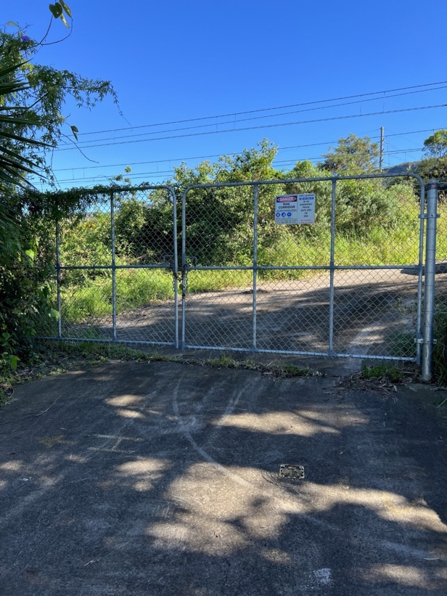  Image 1: Access gate I00 69.286 to protection placed at 69.200 KM (Cochrane Rd) |  | 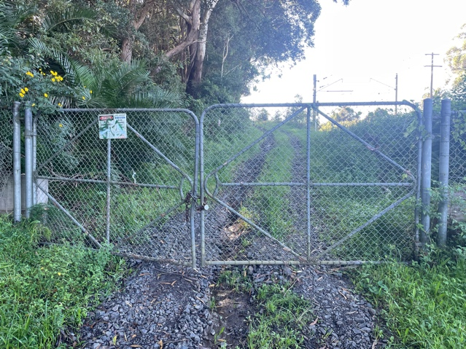  Image 2: Access gate I00 68.188 to protection placed at 67.950 KM (Rail access road off Railway Ave)
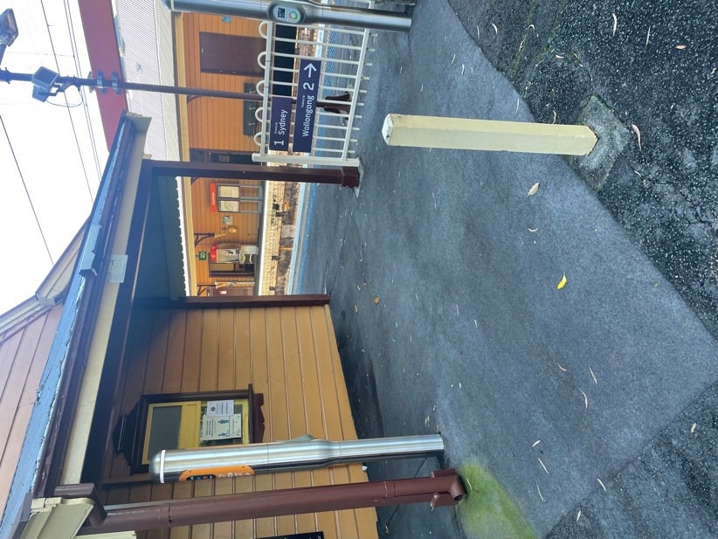
Image 3: Worksite access/egress (Austinmer Station)
HANDSIGNALLER LOCATION:  EXAMPLE ONLY | Image 4: Inner Handsginaller at …… | Image 5: Inner Handsginaller at ……
POINTS TO BE CLIPPED AND LOCKED  EXAMPLE ONLY | 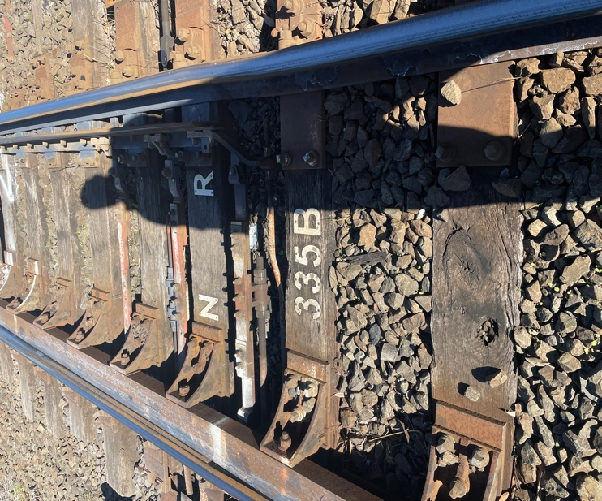Image 6: 335 points | 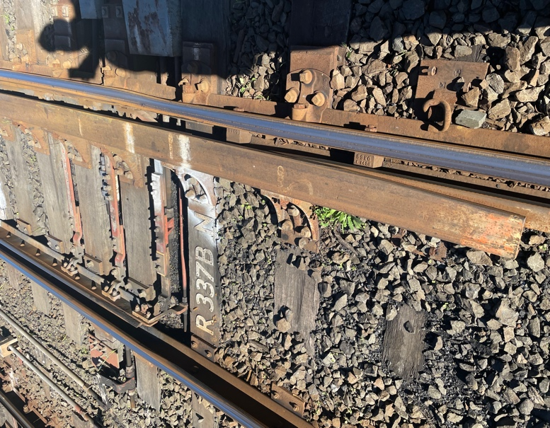  Image 7: 337 points

Protection Officer’s diary
Date | Time | Notes

