DOCUMENT NO. | (provided by SMS document controller)
WORK DESCRIPTION | ……………..
WPP Number | (provided by NR specialist)
SCOPE: | This SWI is applicable for the worksite protection arrangements using TOA for routine ………. performed by ……..  Work activities include:
AUTHORISATIONS: | Protection Officer: Protection Officer Level 2 or higher.  Placing TOA Protection: Handsignaller Level 1 or higher, or Protection Officer Level 1 or higher.
SAFETY CONTROLS – Track Occupancy Authority (TOA) | The TOA limits are from:  - ………. and ………… on the ……………. line.  - ………. and ……….. on the …………….. line.  Protection is placed at:  - Railway Track Signal protection and Worksite Protection Markers at XX.XXXX KM and XX.XXXX KM.  - XXX and XXX points are clipped and locked to prevent unauthorised entry into the TOA.
PRESTART REQUIREMENTS: | Protection Officer assessment checklist must be completed before instructions in this SWI are followed.  Tools and equipment required:  Protection Officer requires a phone to contact the Signaller.  Qualified Workers clipping and locking points require ……  Qualified Workers placing protection require:  - …..x Railway Track Signals  - …..x Worksite Protection Markers  - …..x Tangential / Standard point clips  - ……x SL locks and 1x SL key
FURTHER INFORMATION: | NWT 300 Planning work in the Rail Corridor  NWT 304 Track Occupancy Authority  NPR 702 Using a Track Occupancy Authority  NPR 707 Clipping points  NRF 002 Track Occupancy Authority (TOA)  NPR 712 Protecting work from rail traffic on adjacent lines  NGE 200 Walking in the Danger Zone  NLA XXX ……..

Protection Officer assessment checklist
Protection Officer’s name: |  |  | Yes  (Tick if Yes)
This document has not expired 12 months beyond the issue date.
On-site safety assessment has been completed and additional hazards and controls recorded on the pre-work briefing (Page 3).
SWI details and protection arrangements have been reviewed and validated for the assessed worksite location.
Corridor Safety Number | Protection Officer Signature | Date

Warning
If an above item does not apply, the Protection Officer must not use this Safe Work Instruction. A new worksite protection plan must be completed in accordance with NRF 014 Worksite Protection Pre-work briefing and NRF 015 Worksite Protection Plan.

Worksite Protection Pre-work Briefing
Briefing date: | / /

Protection Officer details
name |  | signature |  | contact No.

Work location:

Scope of work:

Worksite protection: | TOA | Refer to Worksite Protection Plan for details

Hazards (e.g. Site specific hazards identified, including physical environment, human errors, plant and equipment) | Controls (to be implemented to eliminate or reduce the risk to the lowest practicable level) | Person responsible for Control
Approaching rail traffic | TOA implemented. | Protection Officer
Adjacent live lines | Designated work and walk areas as per Protection Officer’s instructions. All work must stop when warned by Protection Officer until rail traffic has passed. | Protection Officer
Electrical infrastructure | Electrical infrastructure is to be treated as live and workers must maintain a safe approach distance as instructed by the Protection Officer or Workplace Supervisor. | Protection Officer  &  Workplace Supervisor
Mobile phone distraction | Mobile phone usage is only allowed in the Danger Zone when required for work purposes.  Other than being used for work purposes, mobile phones may be used only in a safe place after informing the Protection Officer. | All

Workplace Supervisor details

name |  | contact No.

Emergency assembly point: | Access Gate | SWMS/SWI Ref #:

First aid kit location: | Sydney Trains work vehicle | First aider:

Workplace Supervisor acknowledgement

The Workplace Supervisor acknowledges that all identified WHS and rail safety hazards have the appropriate controls in place to manage and/or eliminate the hazards. | Yes | signature

Participant Acknowledgement

NOTE: Recipients of the briefing are to question the Briefer if they don’t understand any part of this briefing.
All workers listed below acknowledge that they:
1. have been inducted to the site  2. are free from alcohol and drugs  3. are free from the effects of fatigue  4. hold the applicable and current Rail Safety Worker Authorisation, trade licence and/or induction record e.g. Construction Industry Induction  5. must wear the appropriate Personal Protective Equipment (PPE) |  | 6. have been briefed on the contents of the Worksite Protection Plan  7. have been shown the Worksite Protection Plan diagram  8. understand the kinds and limits of worksite protection in place  9. have been briefed about any new hazards and controls identified during the final site inspection (final site inspection must be conducted immediately before commencing work)
Mark each check box below with a tick if the item applies or a cross if the item does not apply.
have been informed of the requirements of the electrical permit (if required)  have been briefed on the SWMS/SWIs/documented safe work practice for the job  have been instructed in the controls recorded in this document and SWMS/SWIs |  | have been made aware of any hazardous materials/substances on site  have been briefed on Safety Data Sheets (SDS)  have been briefed on the WHS Management plan  have been briefed on the hazards of adjoining worksites/processes.
Name | Signature | Time of briefing:  hh:mm | Amendment briefing:  hh:mm and initial

Worksite Protection Plan – Track Occupancy Authority
Signaller details
name |  | Panel |  | 02 XXXX XXXX
Protection Officer details
name |  | signature |  | contact No.

RSW or RIW No. |  | designation | Planned duration

Workplace Supervisor details:

Type of work:

Worksite location
on the
between |  | and
on the
between |  | and

The following are diagrams, notes and detailed instructions. These are to be read and followed as part of this worksite protection plan for TOA.

INSTRUCTIONS: | - Workers enter the rail corridor via ………..  - Protection Officer conducts the worksite protection pre-work briefing.  - Protection Officer contacts the Signaller at …………… Panel and requests TOA.  - Instruct Qualified Workers to place Railway Track Signal protection and Worksite Protection Markers at ………… KM and ……….. KM on the …………… lines.  - Instruct Qualified Workers to clip and lock ……… points to prevent rail traffic entry into the TOA.  - Protection Officer informs the workplace supervisor that it is safe for work to start.  - Workers start work.  - After all work is completed, move all workers and equipment into a safe place.  - Instruct Qualified Workers to remove Railway Track Signal protection, Worksite Protection Markers and point clips from the TOA.  - Workers egress the rail corridor via ………..  - After all protection is removed, Protection Officer contacts the Signaller ……………. Panel that work is complete, all protection has been removed from the line, workers and equipment are clear of the Danger Zone and if any restrictions have beem applied to fulfil the TOA.
ADDITIONAL DETAILS
ACCESS/EGRESS:  EXAMPLE ONLY | 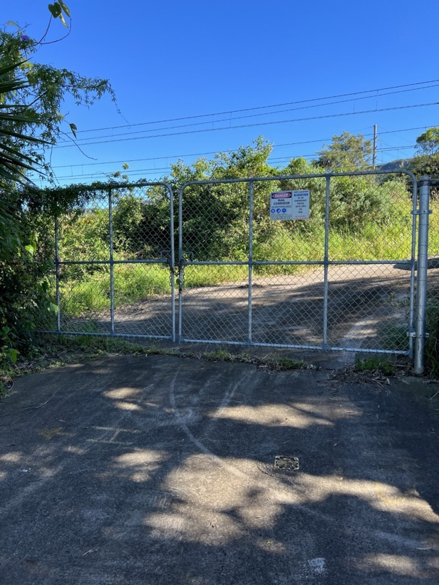  Image 1: Access gate I00 69.286 to protection placed at 69.200 KM (Cochrane Rd) |  | 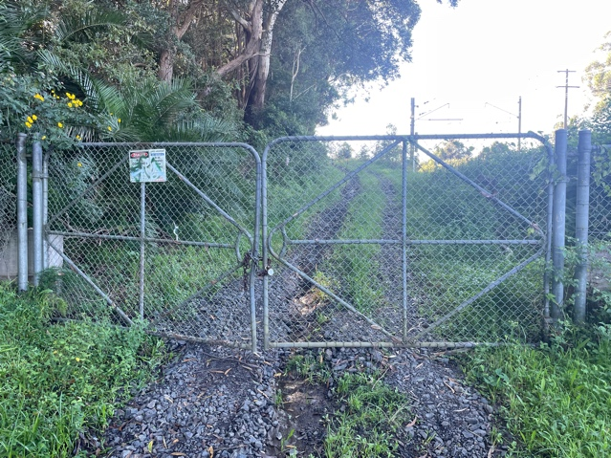  Image 2: Access gate I00 68.188 to protection placed at 67.950 KM (Rail access road off Railway Ave)
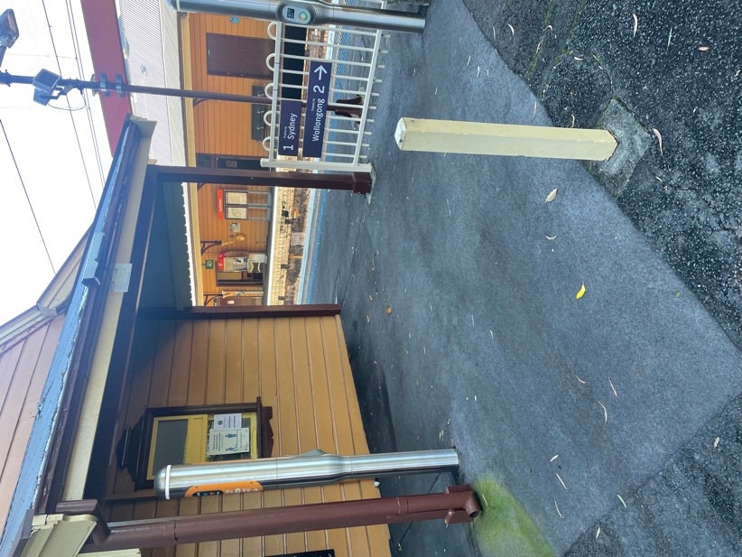
Image 3: Worksite access/egress (Austinmer Station)
TOA LIMITS:  EXAMPLE ONLY | 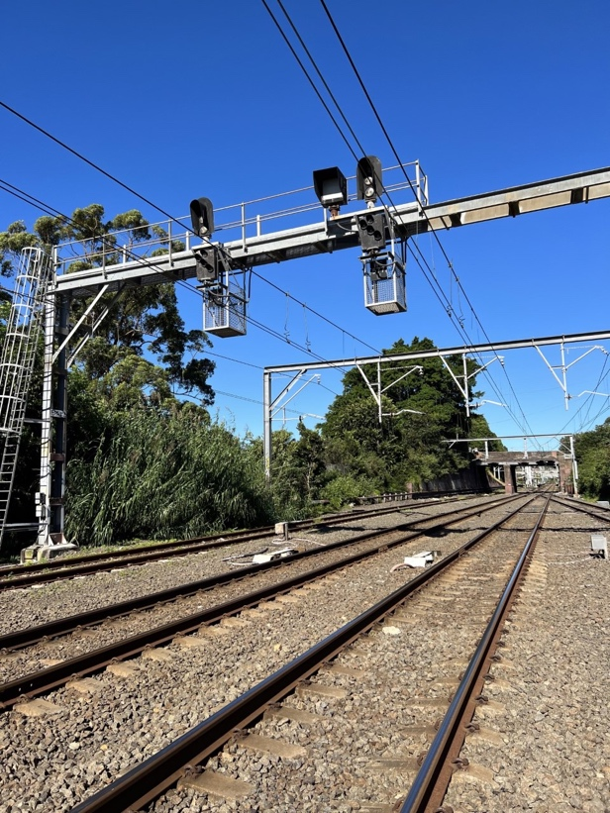Image 4: TOA limits at WG 575 D Signal and WG 577 U Signal | 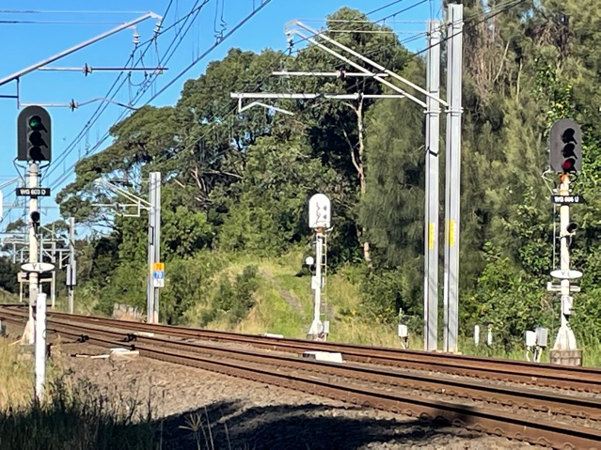Image 5: TOA limits at WG 603 D Signal and WG 605 U Signal
POINTS TO BE CLIPPED AND LOCKED  EXAMPLE ONLY | 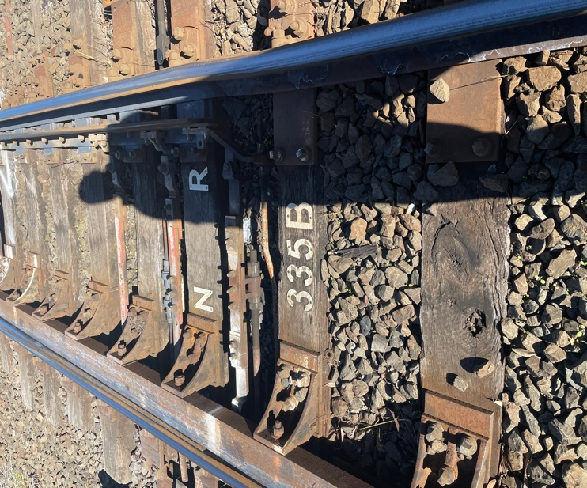Image 6: 335 points | 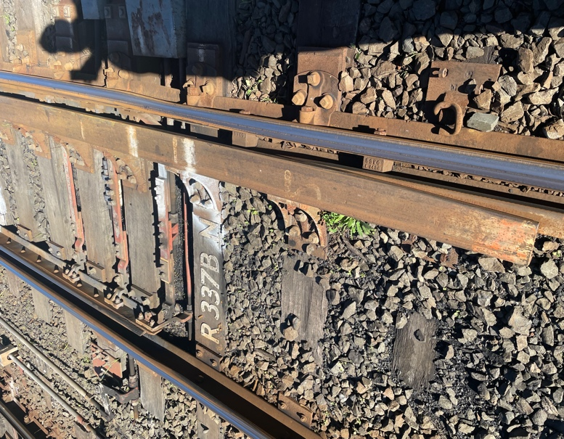  Image 7: 337 points

Diagram
Insert diagram

Protection Officer’s diary
Date | Time | Notes

